**EXPERIMENT 3**

**IMPLEMENTATION OF MULTI-ARMED BANDITS USING OPEN GYM AI API**

Code

import gym

import gym_bandits

import numpy as np

import warnings

import matplotlib.pyplot as plt

warnings.filterwarnings("ignore")

env = gym.make('MultiarmedBandits-v0', disable_env_checker=True)

n_arms = env.action_space.n

num_episodes = 500

epsilon = 0.1

q_values = np.zeros(n_arms)

counts = np.zeros(n_arms)

reward_sums = np.zeros(n_arms)

all_rewards = []

action_history = []

for episode in range(num_episodes):

env.reset()

if np.random.rand() < epsilon:

action = env.action_space.sample() # Explore

else:

action = np.argmax(q_values) # Exploit

observation, reward, done, info = env.step(action)

counts[action] += 1

reward_sums[action] += reward

q_values[action] = reward_sums[action] / counts[action]

all_rewards.append(reward)

action_history.append(action)

env.close()

print("Estimated Q-values for each arm:", np.round(q_values, 2))

print("Number of times each arm was selected:", counts.astype(int))

print("Average reward over all episodes:", round(np.mean(all_rewards), 3))

plt.figure(figsize=(14, 5))

plt.subplot(1, 2, 1)

plt.plot(np.cumsum(all_rewards), color='blue')

plt.title("Cumulative Reward Over Episodes")

plt.xlabel("Episode")

plt.ylabel("Cumulative Reward")

plt.subplot(1, 2, 2)

plt.bar(np.arange(n_arms), counts, color='green')

plt.title("Action Selection Frequency")

plt.xlabel("Arm Index")

plt.ylabel("Times Selected")

plt.tight_layout()

plt.show()

Output

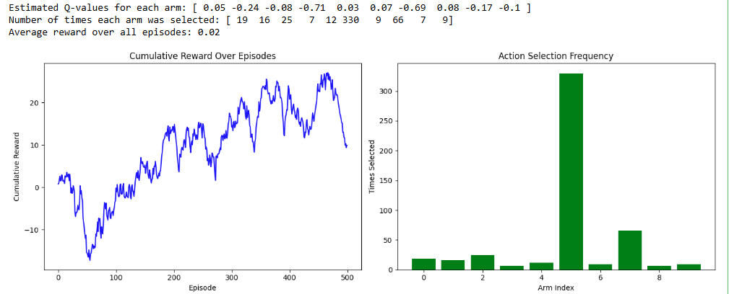

E0123038

MUGESH K